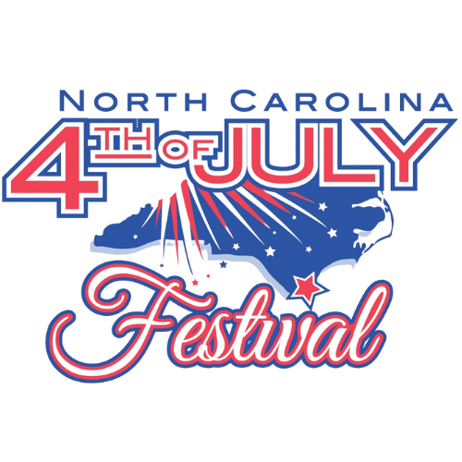

REQUEST FOR PROPOSALS
FOR
NC 4TH OF JULY FESTIVAL

Festival Insurance Coverage

Submit Proposals to:
Allayna D. Taylor
adail@cityofsouthport.com
Director, Community Relations
Mail: P. O. Box 11247, Southport NC 28461
Physical: 1029 N. Howe St., Southport, NC 28461

TABLE OF CONTENTS
INVITATION ……………………………………………..…………………………………..……………………………..3
BACKGROUND ……………………………………………..……………………………………………………………..3
SOLICITATION TIMELINE ……………………………………………..……….………………………………………..3
SUBMISSION OF PROPOSALS ……………………………………………..…...……………………………………..3
EX-PARTE COMMUNICATIONS ……………………………………………..……………………………..…………..3
FESTIVAL RESPONSIBILITIES ……………………………………………..…………………………………………..3
PROJECT PURPOSE & BACKGROUND ……………………………………………..………………………………..3
SCOPE OF COVERAGE ……………………………………………..…………………………………………………..3
COVERAGE PERIOD ……………………………………………………………………………………………………..4
SAMPLE EVENT CALENDAR ……………………………………………………………………………………………4
PROPOSAL REQUIREMENTS …………………………………………………………………………………………..5
EVALUATION CRITERIA ……………………………………………………..…………………………………………..5
1. INVITATION
The NC 4th of July Festival, Inc. invites licensed and qualified insurance providers to submit proposals for comprehensive special event insurance coverage for the 2026 NC 4th of July Festival. Coverage must include a range of high-attendance public activities and should be tailored to the unique risks associated with our week-long patriotic celebration.
Now in its 225th year, the NC 4th of July Festival is a Southport institution and one of the oldest Independence Day festivals in the nation. It attracts thousands of visitors and includes a parade, concerts, fireworks, art shows, petting zoos, and other family-oriented programming.
2. BACKGROUND
The Festival has historically carried commercial general liability coverage with no less than $2,000,000 in aggregate limits, including protection for parades, vendors, food service, fireworks exhibitions, and volunteer operations. We are seeking proposals for equivalent or enhanced coverage.
3. SOLICITATION PROCESS AND PROPOSAL EVALUATION
The festival intends to adhere to the following timeline (subject to change at the Festival's discretion):
RFP Issued September 1, 2025
Questions Due October 15, 2025
Proposal Due Date October 31, 2025
Selection Notification November 30, 2025
4. SUBMISSION OF PROPOSALS
Proposals must be submitted via email to adail@cityofsouthport.com. If mailing, please address to NC 4th of July Festival, P. O. Box 11247, Southport NC 28461. Late submissions will not be accepted.
5. EX-PARTE COMMUNICATIONS
All questions must be directed via email. Communication with Festival staff outside of the designated channels is discouraged.
6. FESTIVAL RESPONSIBILITIES
The Festival will provide past insurance policies, layout maps, expected attendance, and supporting documents to assist in risk assessment.
7. PROJECT PURPOSE & BACKGROUND
The insurance policy must protect the NC 4th of July Festival, Inc. from risks related to bodily injury, property damage, advertising injury, and more, during the execution of large-scale public events.
8. SCOPE OF COVERAGE
Required Coverage Minimums:

- General Aggregate Limit: $2,000,000
- Each Occurrence Limit: $1,000,000
- Personal & Advertising Injury: $1,000,000
- Damage to Rented Premises: $100,000
- Medical Expense: $5,000 per person
Must Include:
- Fireworks
- Parade
- Skydiving appearances (e.g., “Uncle Sam Skydiver” style entries)
- Food vendors
- Petting zoos, inflatables, and live performances
- Volunteer and board member coverage
- Tents and temporary structures
Additional Insureds & Certificates on request
Surplus Lines documentation (if applicable)
24/7 Claims reporting
9. COVERAGE PERIOD
Policy must cover the full operational window of the event, from June 26, 2026 through July 4, 2026.
10. SAMPLE EVENT CALENDAR
Below is a representative selection of 2025 events to illustrate the scope of activity expected:
- Parades with floats
- Live music concerts with dancing (street dance)
- Fireworks over the waterfront (via barge)
- Uncle Sam Skydiver performance
- Petting zoo, pony rides, and inflatable kid zones
- Food & craft vendors
- Naturalization ceremony and keynote speakers
- Competitive games (baby crawling, cornhole, etc.)
- Military displays and vehicle exhibits
- Wrestling exhibitions
- Art shows and gallery events
- Fun runs, fitness activities, and beach day contests
NOTE:
We ask all proposers to identify any exclusions, limitations, or elevated risk premiums associated with these types of activities in their proposal. Your feedback will help us shape final programming and mitigate risk.

11. PROPOSAL REQUIREMENTS
- Letter of Introduction (brief company overview and commitment to coverage)
- Coverage Summary (detailed quote, policy limits, deductibles, exclusions)
- Certificate of Insurance sample
- Pricing Proposal (all-inclusive quote with fees, taxes, surplus charges)
- Experience with Similar Events
- Claims Support Overview
- Activity Exclusion Disclosure (required per Section 10 above)
12. EVALUATION CRITERIA
Coverage compliance and exclusions
Experience with festivals or municipal events
Cost competitiveness
Responsiveness and clarity
Value-added services (risk management, training, rapid response)

