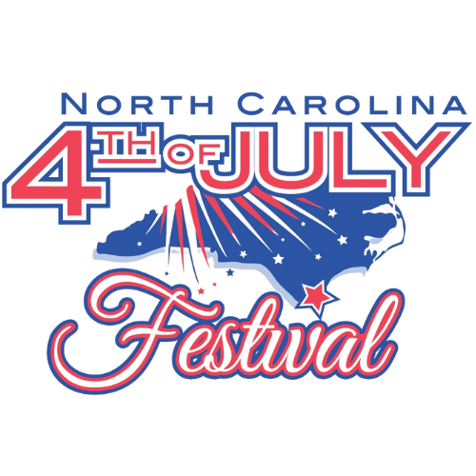

REQUEST FOR PROPOSALS
FOR
NC 4TH OF JULY FESTIVAL

Barge for Fireworks Display

Submit Proposals to:
Allayna D. Taylor
adail@cityofsouthport.com
Director, Community Relations
Mail: P. O. Box 11247, Southport NC 28461
Physical: 1029 N. Howe St., Southport, NC 28461

TABLE OF CONTENTS
INVITATION / BACKGROUND …………………………………………………………………………………………..3
SUBMISSION OF PROPOSALS ………………………………………………………………………………………...3
MODIFICATION, WITHDRAWAL, MISTAKES, AND MINOR INFORMALITIES …………………………………..3
FESTIVAL RESPONSIBILITIES ………………….……………………………………………………………………..3
SCOPE OF SERVICES …………….…………………………..……….………..….…………………………………..3
PROPOSAL CONTENT …………………………………………………………………………………………………..4
1. INVITATION / BACKGROUND

The NC 4th of July Festival, Inc. invites qualified and experienced marine service providers to submit proposals to supply a barge for the Festival’s annual fireworks display on July 4, 2026.

Now celebrating over 225 years of patriotic tradition, the NC 4th of July Festival is one of the oldest Independence Day celebrations, drawing thousands of visitors to historic Southport, North Carolina. The festival features a full slate of events, including a parade, concerts, naturalization ceremony, food and craft vendors, and one of the most anticipated attractions, the waterfront fireworks show.

To ensure the safety and success of the fireworks display, the Festival is seeking a provider who can supply a flat-deck barge and captain for full-day support of the fireworks vendor. Proposals can be submitted in a simple format, as outlined below, to keep the process easy and accessible to all qualified providers.

2. SUBMISSION OF PROPOSALS

To simplify participation, interested providers may submit proposals in the form of:

- A brief email or letter verifying access to a qualifying barge

- A cost estimate on company letterhead

Submit proposals by October 31, 2025

Proposals must be submitted via email to adail@cityofsouthport.com. If mailing, please address to NC 4th of July Festival, P. O. Box 11247, Southport NC 28461. Late submissions will not be accepted.

Activity | Date
RFP Issued | August 20, 2025
Questions Due | October 15, 2025
Proposal Due Date | October 31, 2025
Selection Notification | November 15, 2025

3. MODIFICATION, WITHDRAWL, MISTAKES, AND MINOR INFORMALITIES

Proposals may be modified or withdrawn before the proposal due date. Corrections to proposals must be clearly indicated and re-submitted.

4. FESTIVAL RESPONSIBILITIES

The festival will coordinate site access, provide event schedules, and assist in logistical planning with the pyrotechnic company, Munnerlyn Pyrotechnics.

5. SCOPE OF SERVICES

The selected provider must supply:

- A licensed captain to operate the barge

- A flat deck barge (not a pin barge or trash barge; pin barges are not acceptable under any circumstances)
Minimum size requirements:

- 12,000 sq. ft. if the provider will also supply an additional boat for the pyrotechnic operators to occupy during the display (fireworks will be on the barge, detonation from the boat)

- 20,000 sq. ft. if only a barge will be provided (operators will be on the barge for detonation)

Full-day availability from 7:00 a.m. to 10:00 p.m. on July 4, 2026 for:
- Safety inspection

- Pyrotechnics loading and setup

- 30-minute fireworks display from 9:00 p.m. – 9:30 p.m.

6. PROPOSAL CONTENT

Applicants do not need to submit lengthy proposals. Each submission should include:

- A simple document (email or letter) confirming availability of a qualifying barge

- Provider's name and contact information

- Confirmation of barge specifications

- Availability for the required date and hours

- Cost estimate on letterhead

- Any relevant experience (optional)

